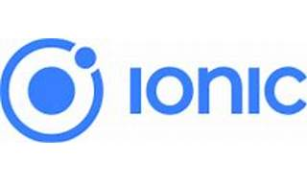



Explore

[**Ionic Framework** is an open-source mobile UI toolkit that allows developers to build modern, high-quality cross-platform mobile apps using web technologies (HTML, CSS, and JavaScript) with integrations for popular frameworks like Angular, React, and Vue](https://ionicframework.com/) [1](https://ionicframework.com/)[2](https://ionicframework.com/docs).

Here are **five free reference links** where you can learn more about Ionic development:

1. [**Ionic Framework Official Documentation**](https://ionicframework.com/docs): Explore the core concepts, UI components, and best practices for building Ionic apps.
2. [**IonicThemes Tutorial: Build a Complete Mobile App**](https://ionicthemes.com/tutorials/build-a-complete-mobile-app-with-ionic-framework): A comprehensive guide to building a real mobile app using Ionic, covering CRUD operations, backend integration, and databases.
3. [**Alison Course: Mobile and Web Development using Ionic**](https://alison.com/course/mobile-and-web-development-using-ionic): Learn how to create websites and mobile applications using the cross-platform Ionic framework.
4. [**freeCodeCamp Tutorial: Learn Ionic 4**](https://www.freecodecamp.org/news/ionic-full-course/): Dive into building a mobile app with Ionic and Angular from scratch.
5. [**Ionic First App Tutorial**](https://ionicframework.com/docs/angular/your-first-app): Get started with Ionic by creating your first app, complete with UI components and native features powered by Capacitor.

Happy learning! 🚀📱